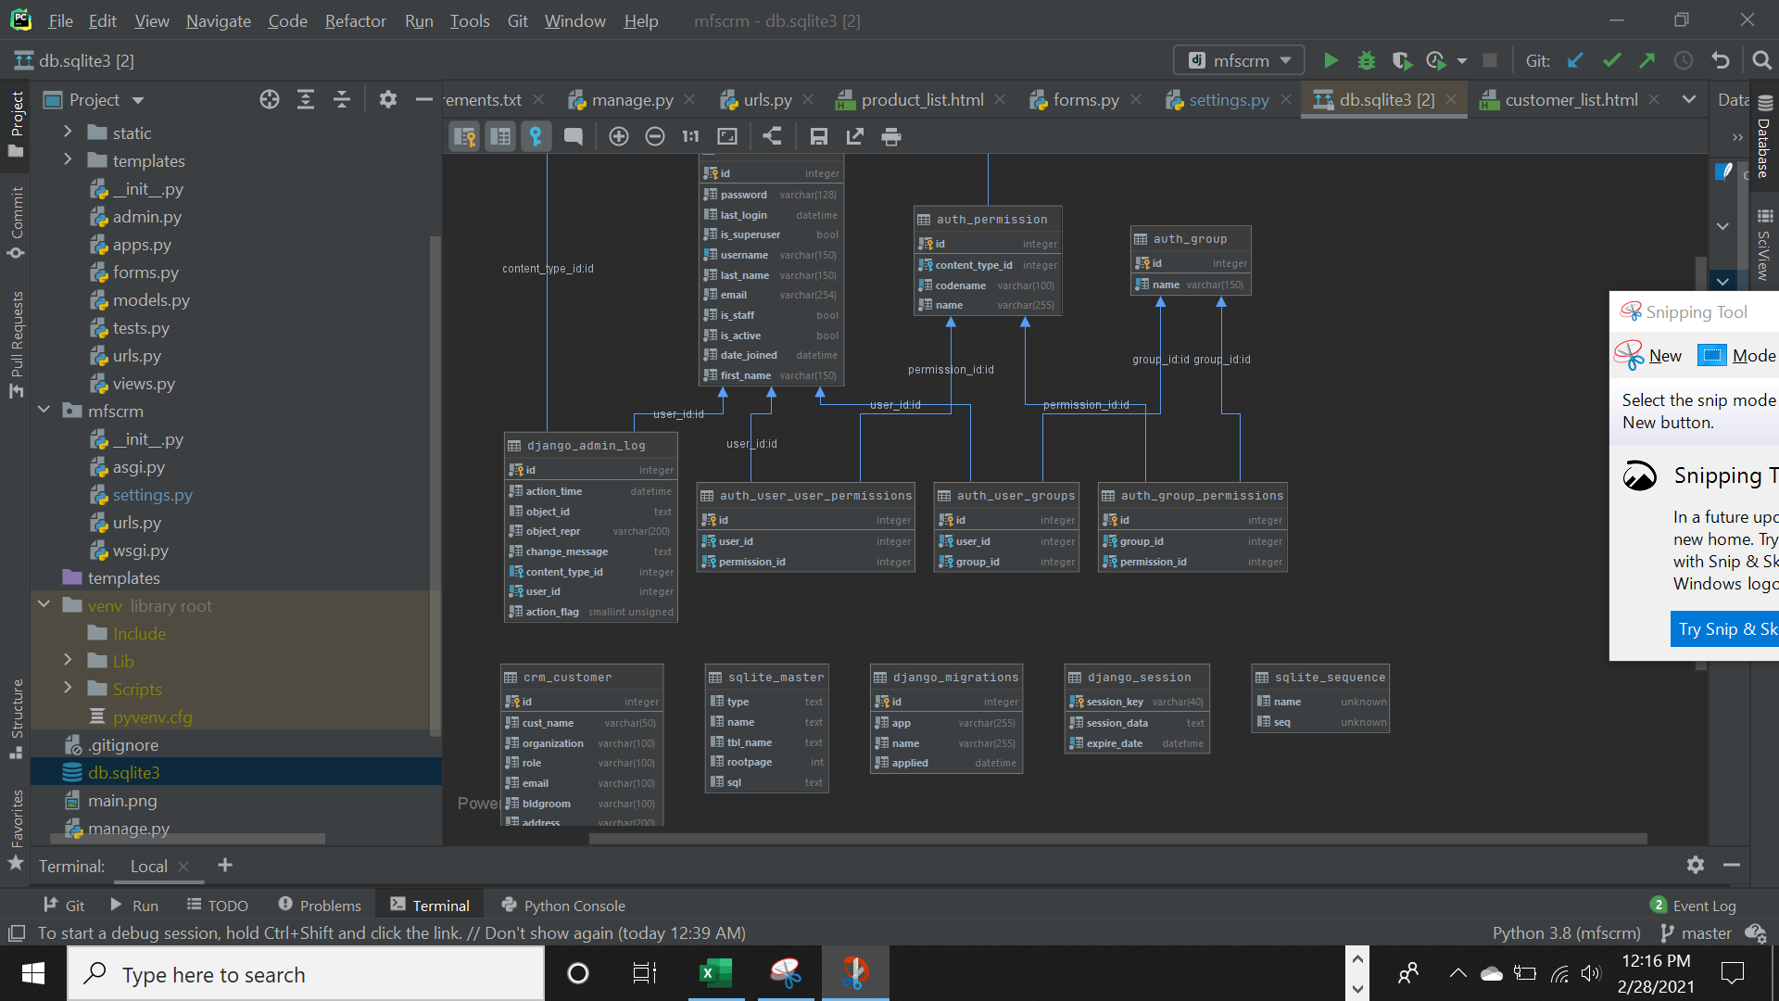

1. This is the UML diagram created in the PyCharm.

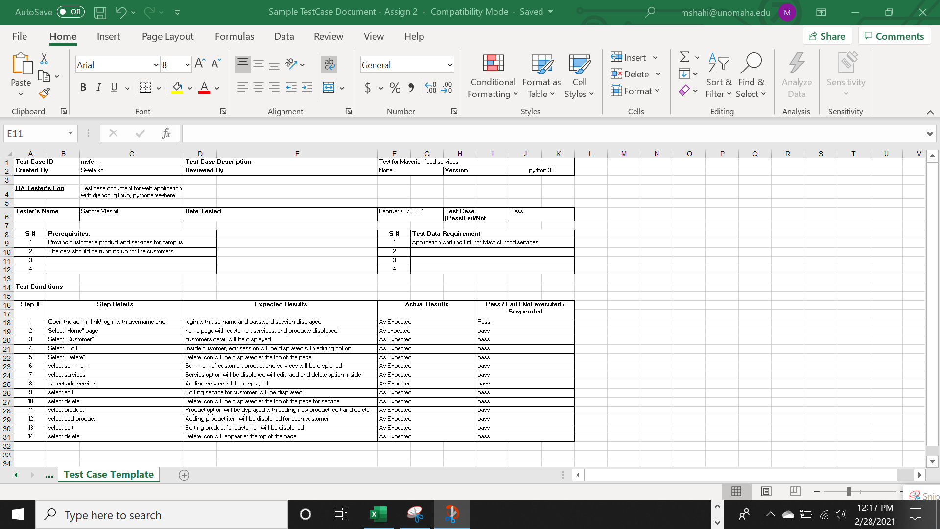

1. This is excel, Test Case Template for this assignment.

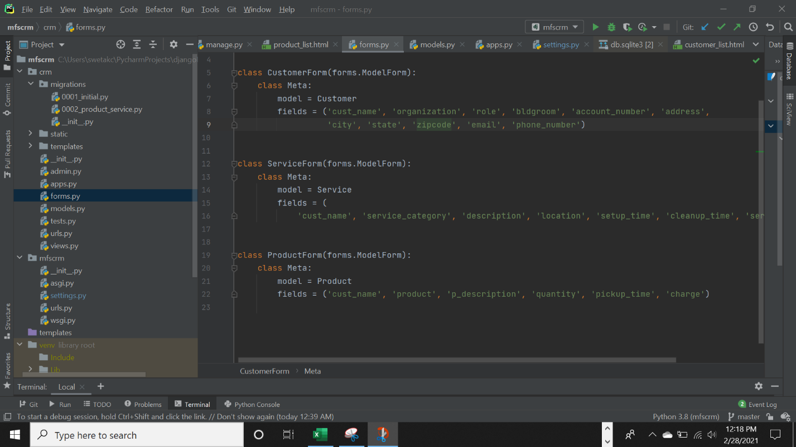

1. This is forms.py created inside the PyCharm for customer, services and products.

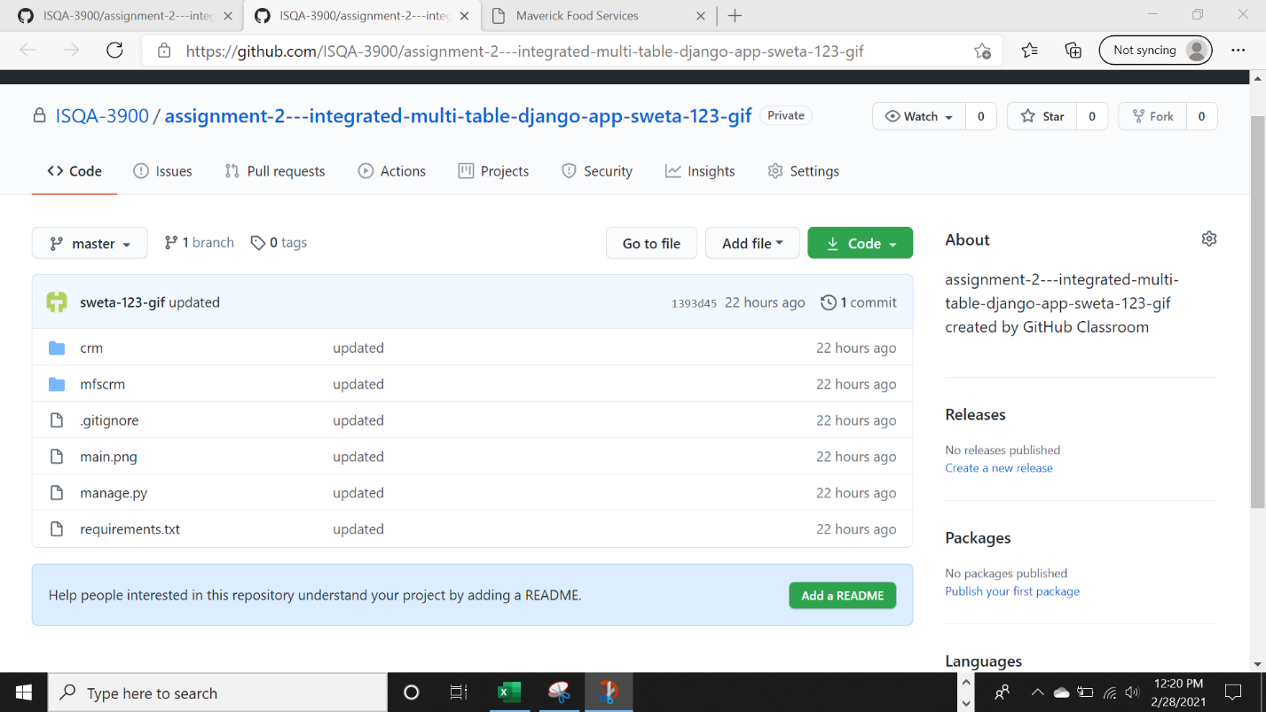

1. This is my GitHub assignment submitted via PyCharm. (Excel file and screenshot yet needs to be added.)

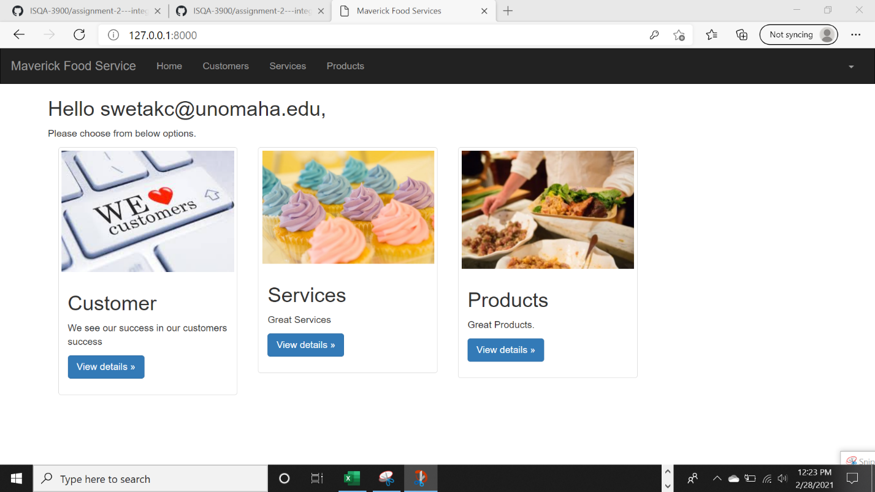

1. This is my home for Maverick food services.

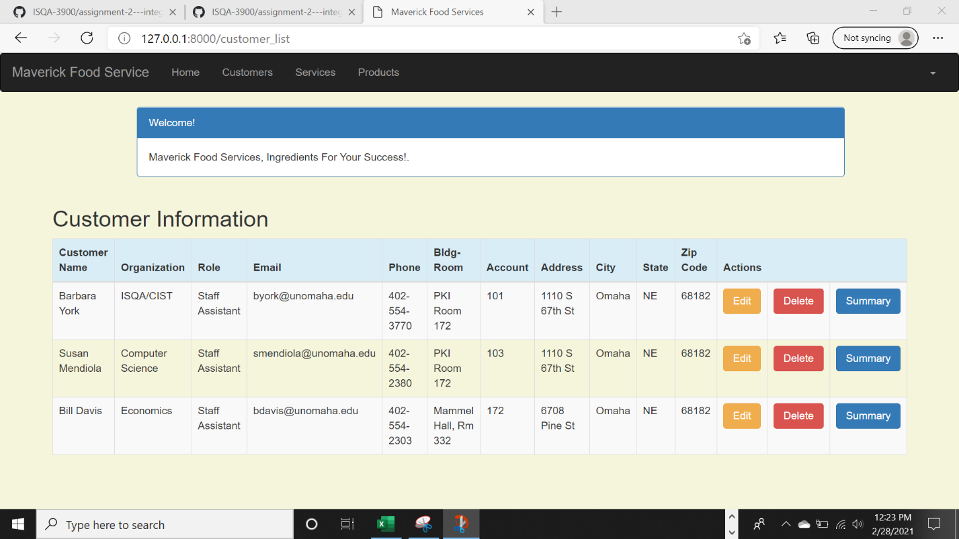

1. This is the customer information page, with edit, delete and summary option.

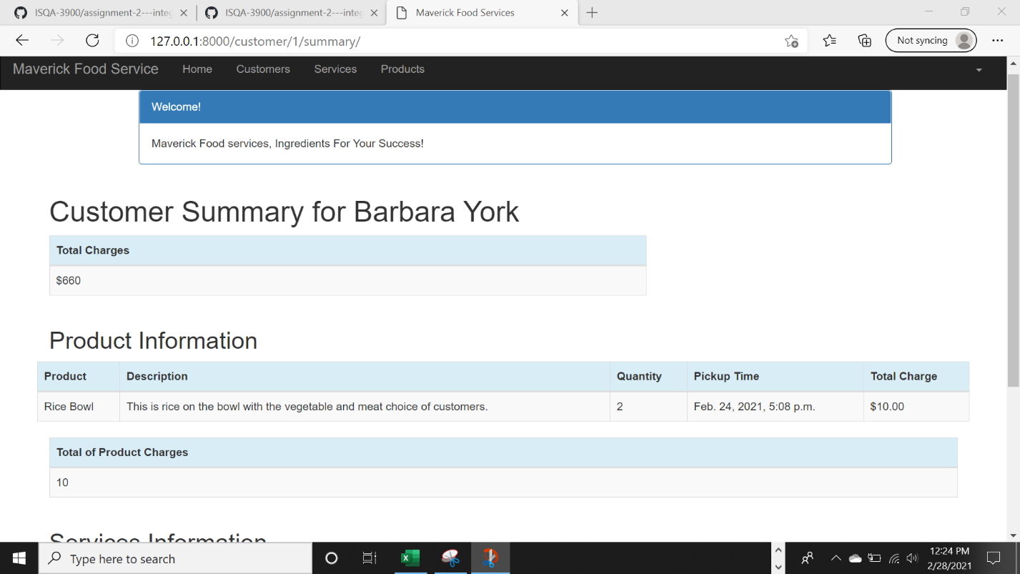

1. This is the customer summary page for Barbara York. (Page to be continued below).

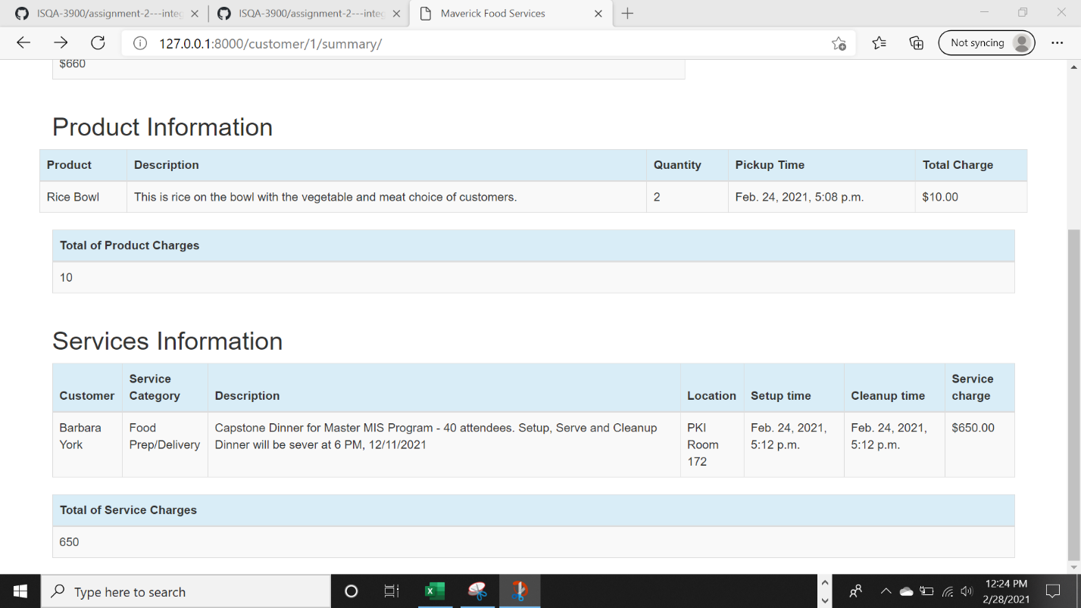

1. This is continued page from above.

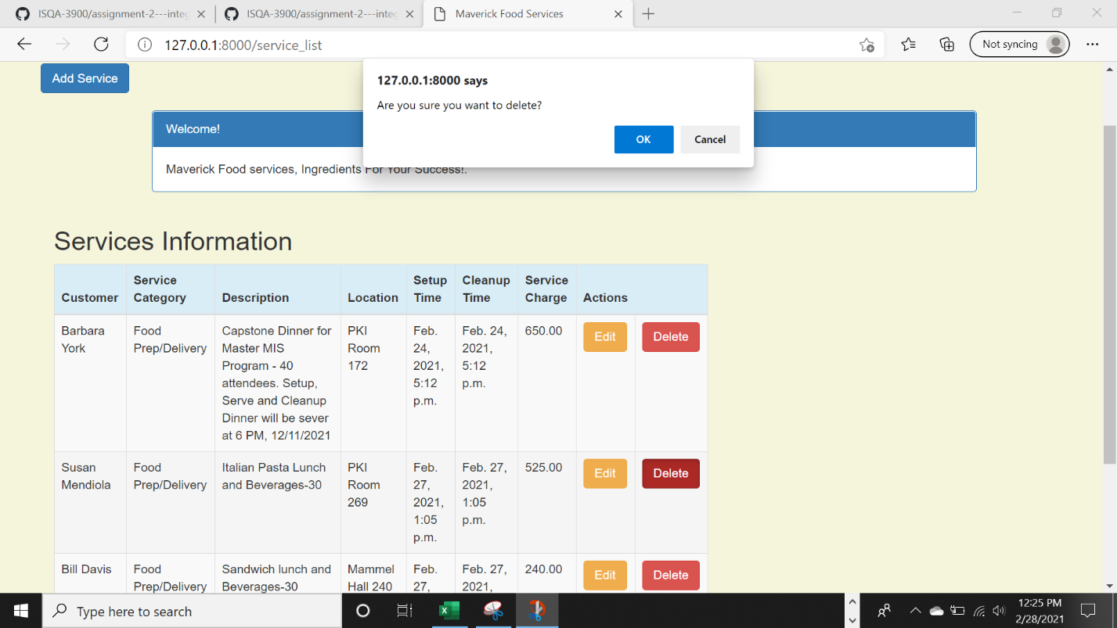

1. This is the services Information page with delete icon open at the top of the page.

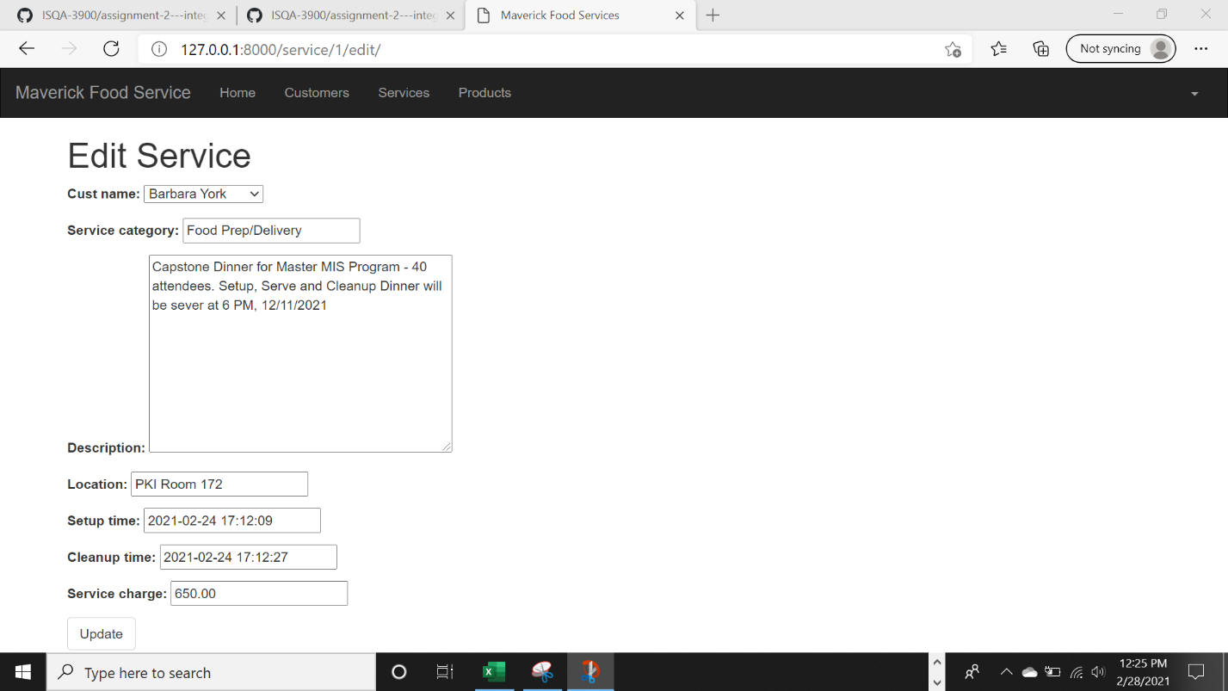

1. This is the edit service page.

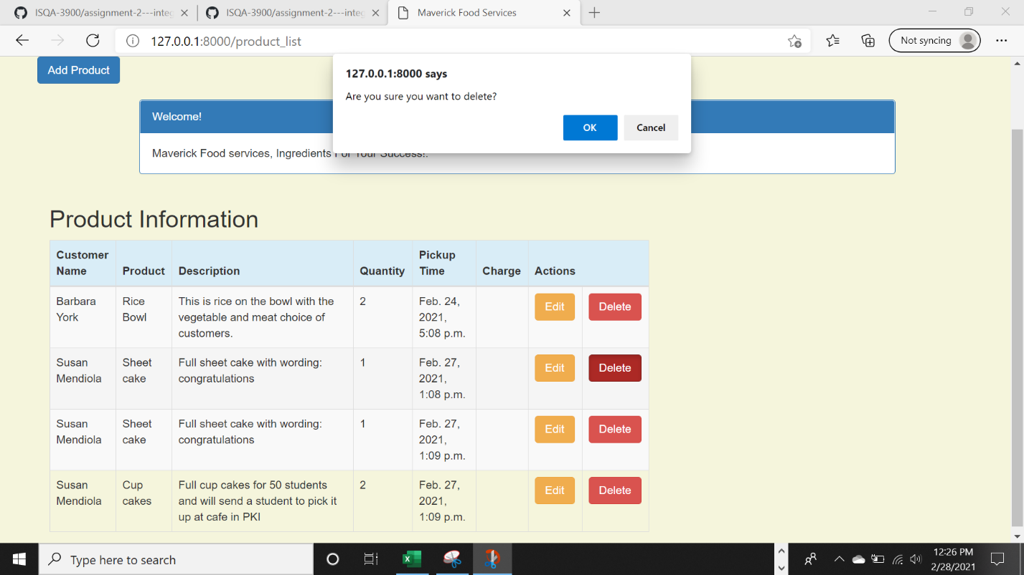

1. This is Product Information page linked with delete icon at the top of the page.

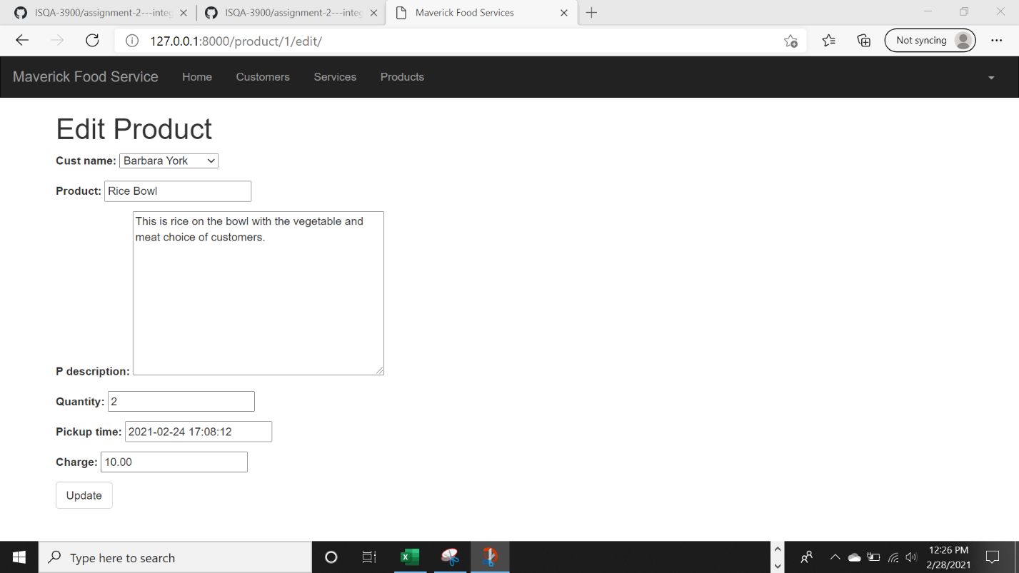

1. This is Edit product page for customer.

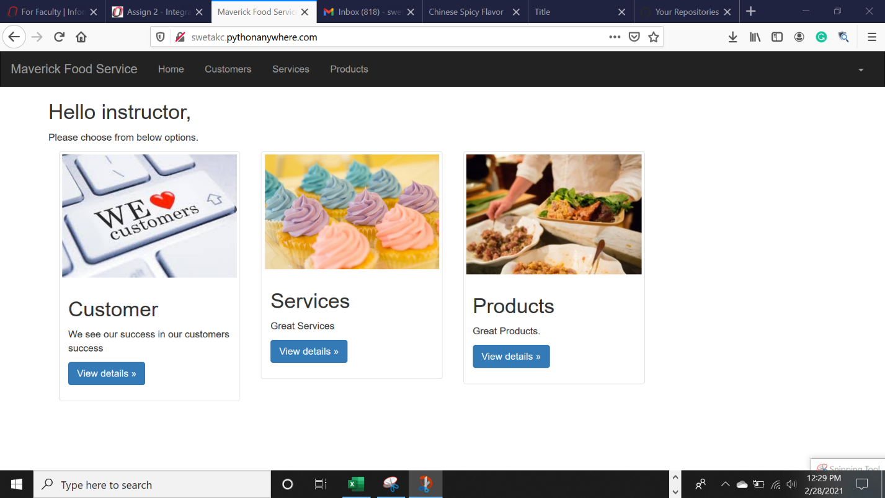

1. This is for instructor page created for instructor. (maverick1)